1. Overview
Bean is a key concept of the Spring Framework. So understanding this notion is crucial to get the hang of the framework and use it in an effective way.
Unfortunately, there aren’t clear answers to the simple question of what a Spring bean really is. Some explanations go to such a low level that the big picture is missed, whereas others are too vague.
This tutorial will try to shed light on the topic, starting with a description in the official documentation.
2. Bean Definition
Here’s a definition of beans in the Spring Framework documentation:
In Spring, the objects that form the backbone of your application and that are managed by the Spring IoC container are called beans. A bean is an object that is instantiated, assembled, and otherwise managed by a Spring IoC container.
This definition is concise and gets to the point but fails to elaborate on an important element: the Spring IoC container. Let’s take a closer look to see what it is and the benefits it brings in.
3. Inversion of Control
Simply put, Inversion of Control (IoC) is a process in which an object defines its dependencies without creating them. This object delegates the job of constructing such dependencies to an IoC container.
Let’s start with the declaration of a couple of domain classes before diving into IoC.
3.1. Domain Classes
Assume we have a class declaration:
public class Company {
private Address address;

public Company(Address address) {
this.address = address;
}

// getter, setter and other properties
}Copy
This class needs a collaborator of type Address:
public class Address {
private String street;
private int number;

public Address(String street, int number) {
this.street = street;
this.number = number;
}

// getters and setters
}Copy
3.2. Traditional Approach
Normally, we create objects with their classes’ constructors:
Address address = new Address("High Street", 1000);
Company company = new Company(address);Copy
There’s nothing wrong with this approach, but wouldn’t it be nice to manage the dependencies in a better way?
Imagine an application with dozens or even hundreds of classes. Sometimes we want to share a single instance of a class across the whole application, other times we need a separate object for each use case, and so on.
Managing such a number of objects is nothing short of a nightmare. This is where inversion of control comes to the rescue.
Instead of constructing dependencies by itself, an object can retrieve its dependencies from an IoC container. All we need to do is to provide the container with appropriate configuration metadata.
3.3. Bean Configuration

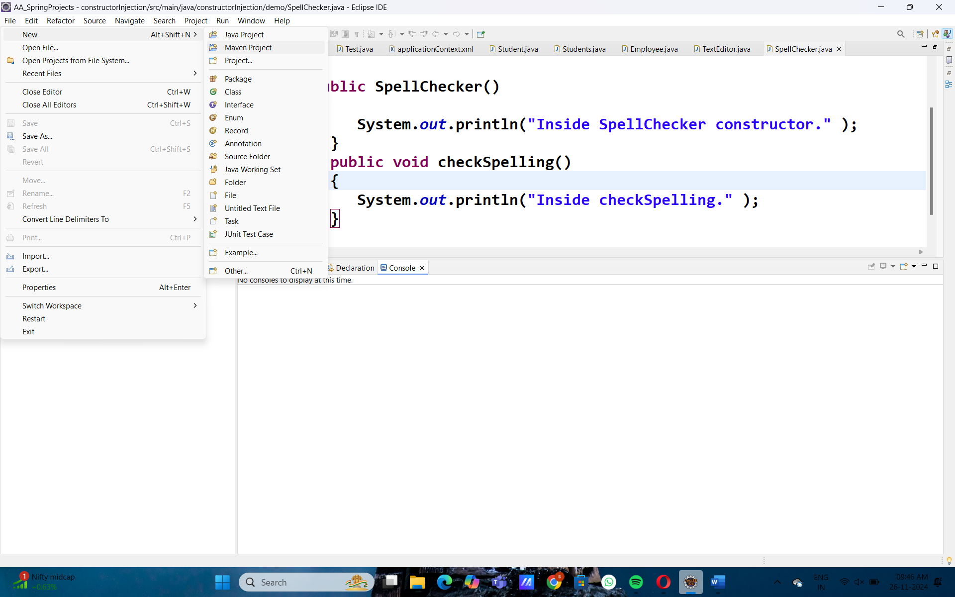

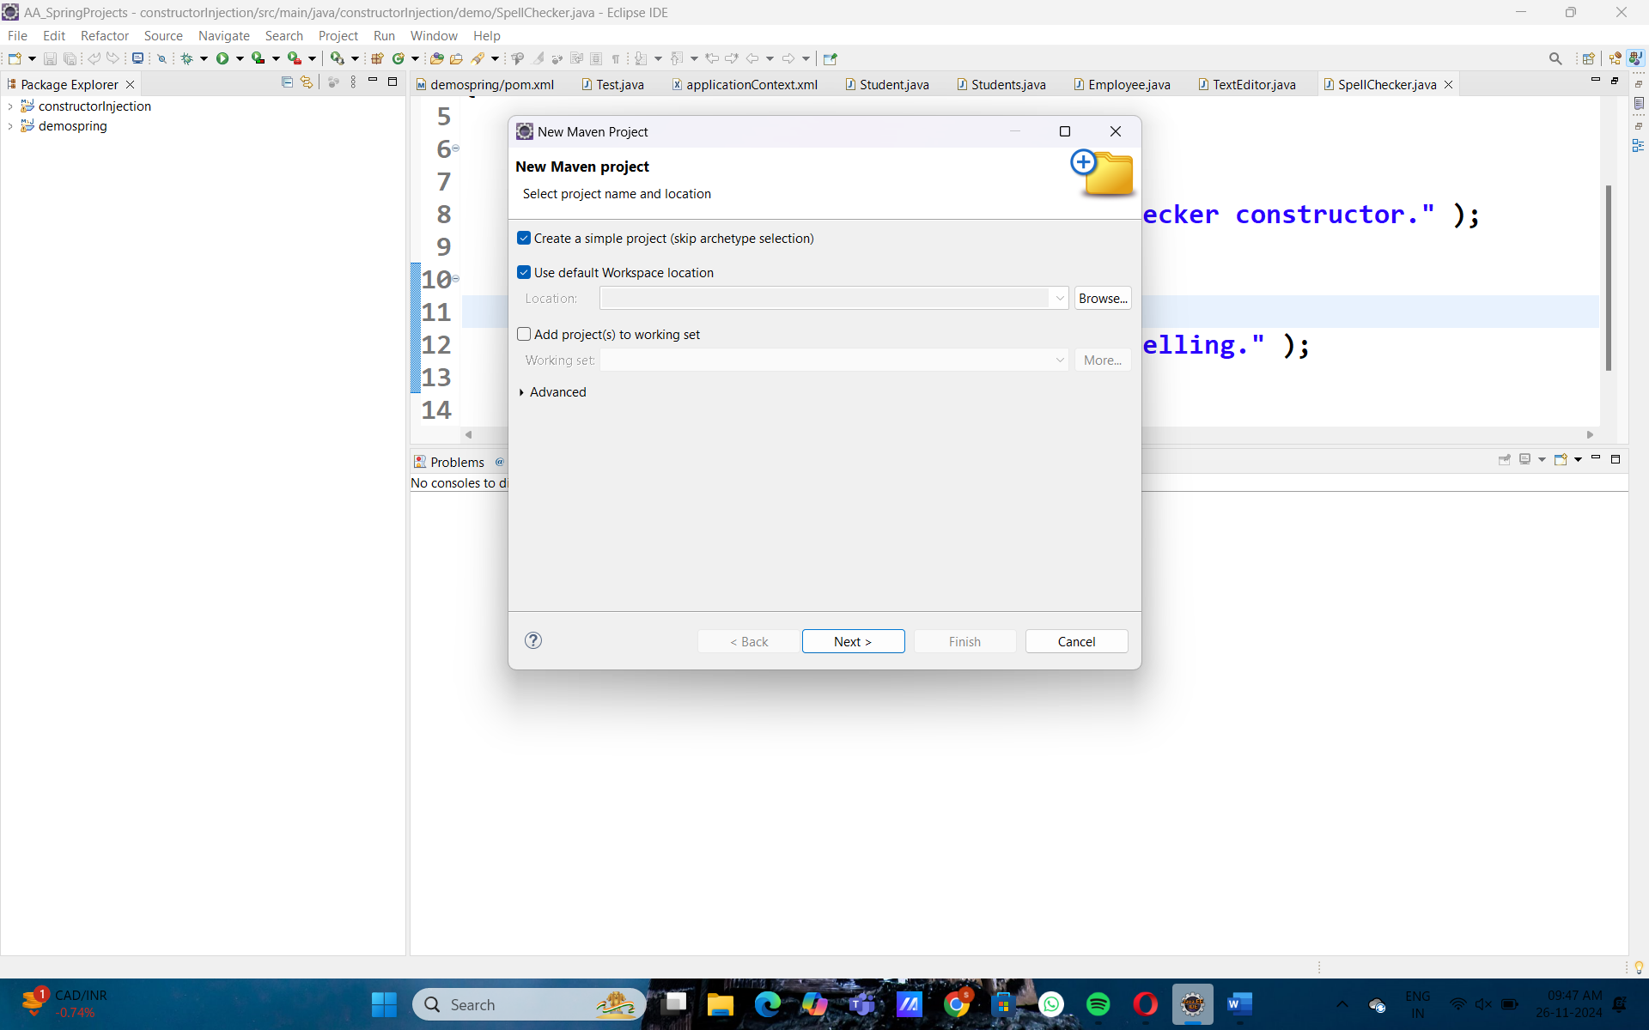
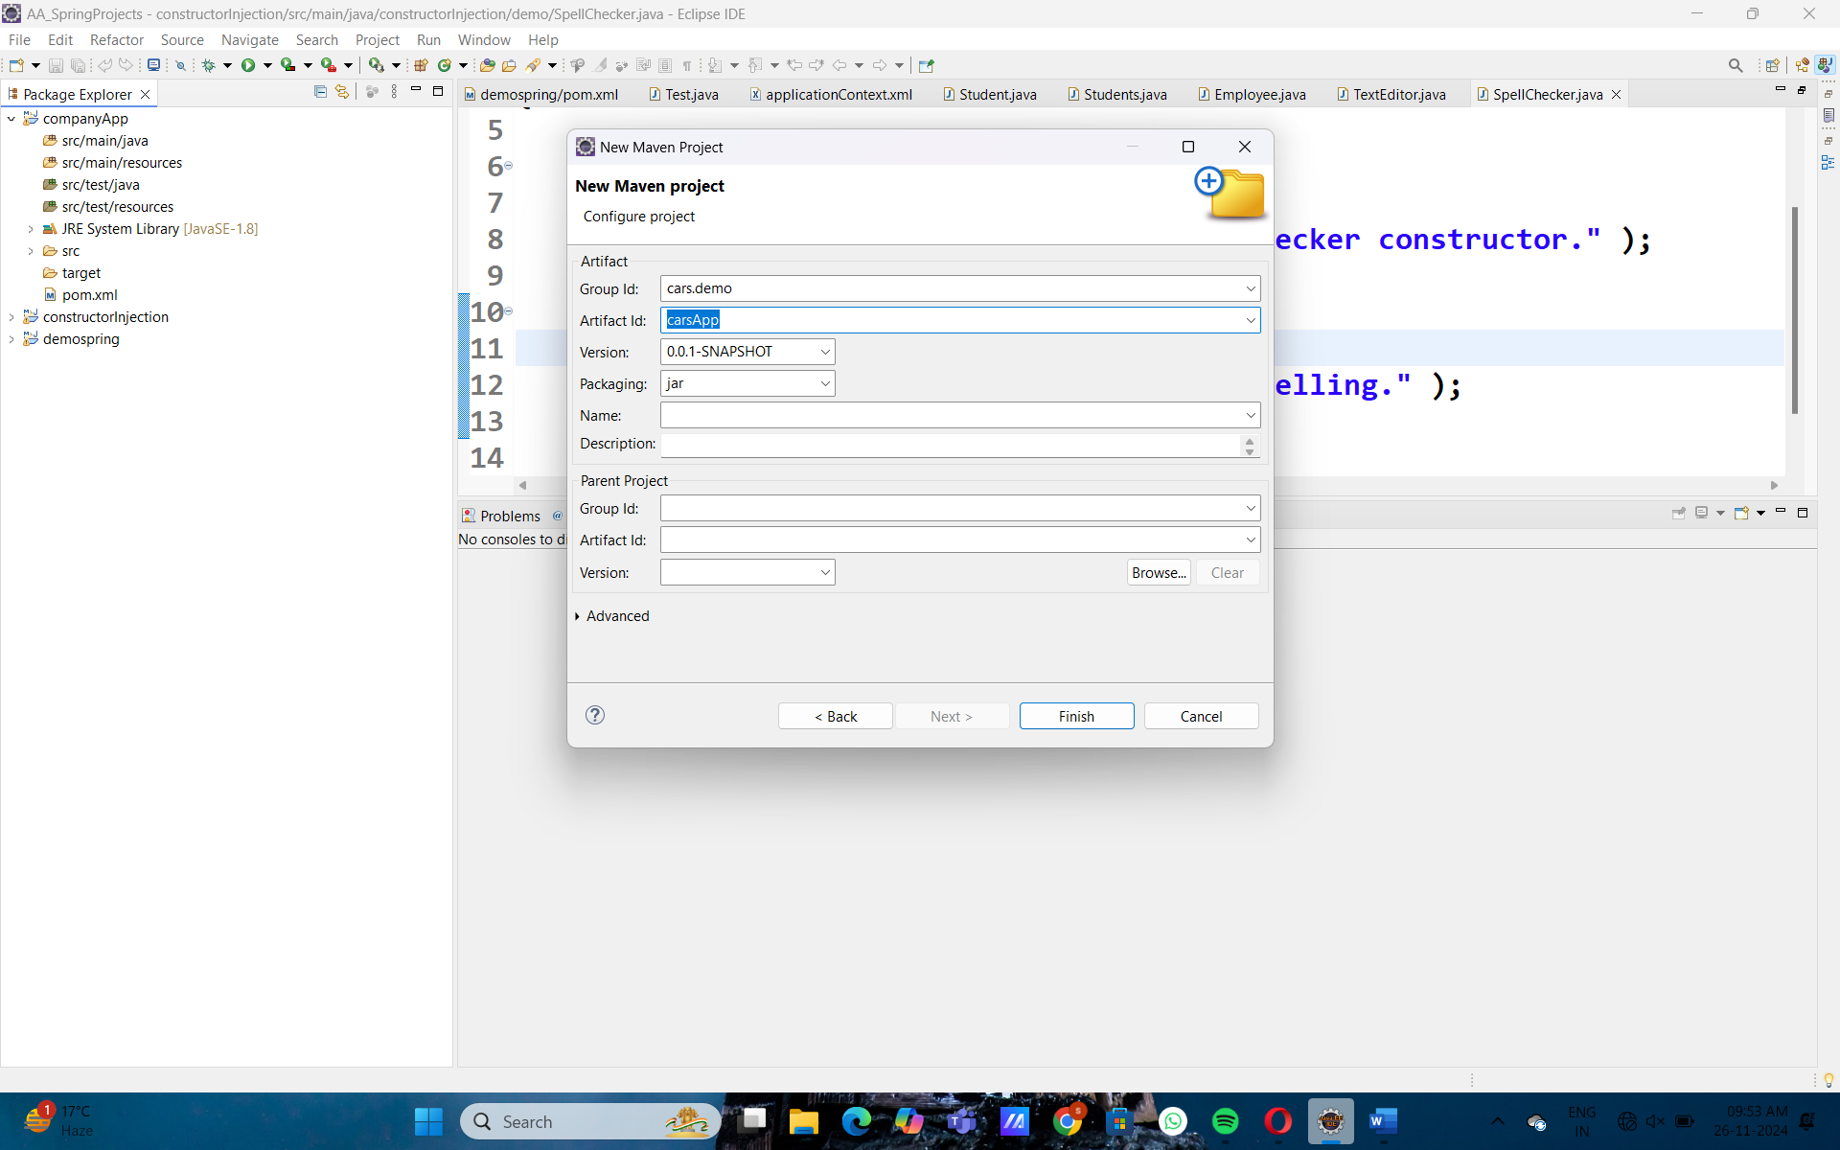
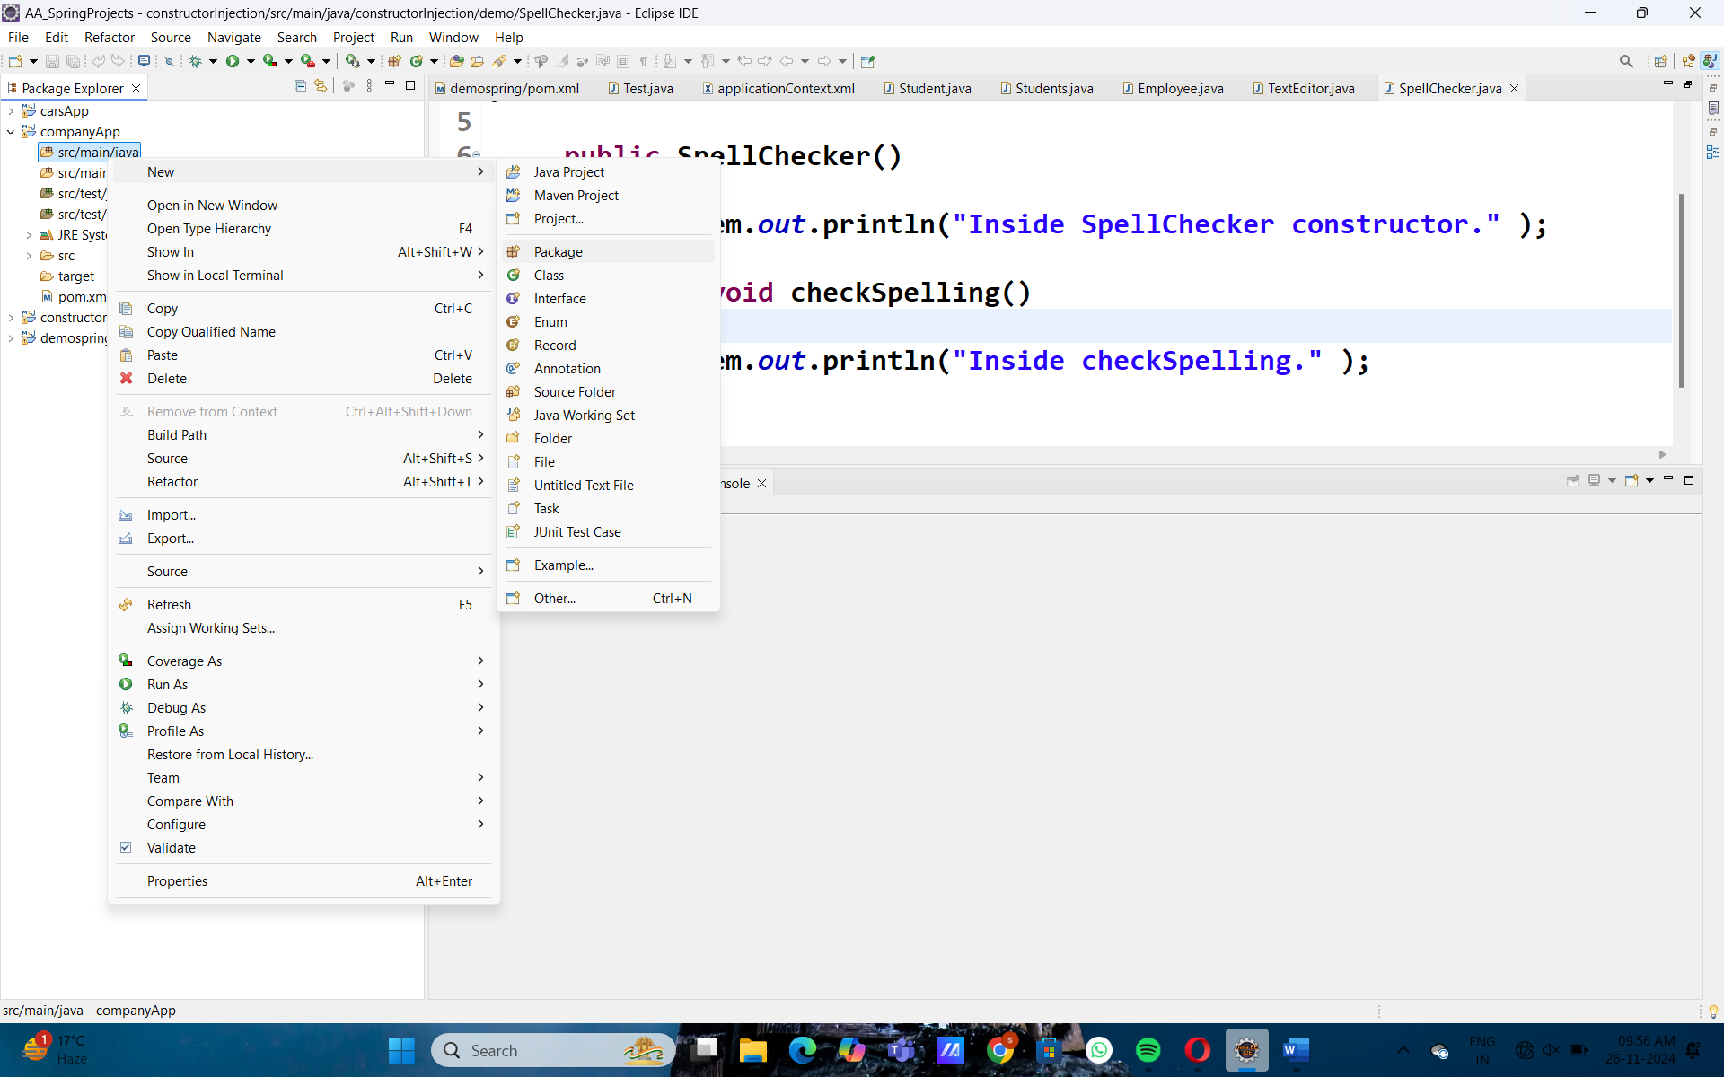
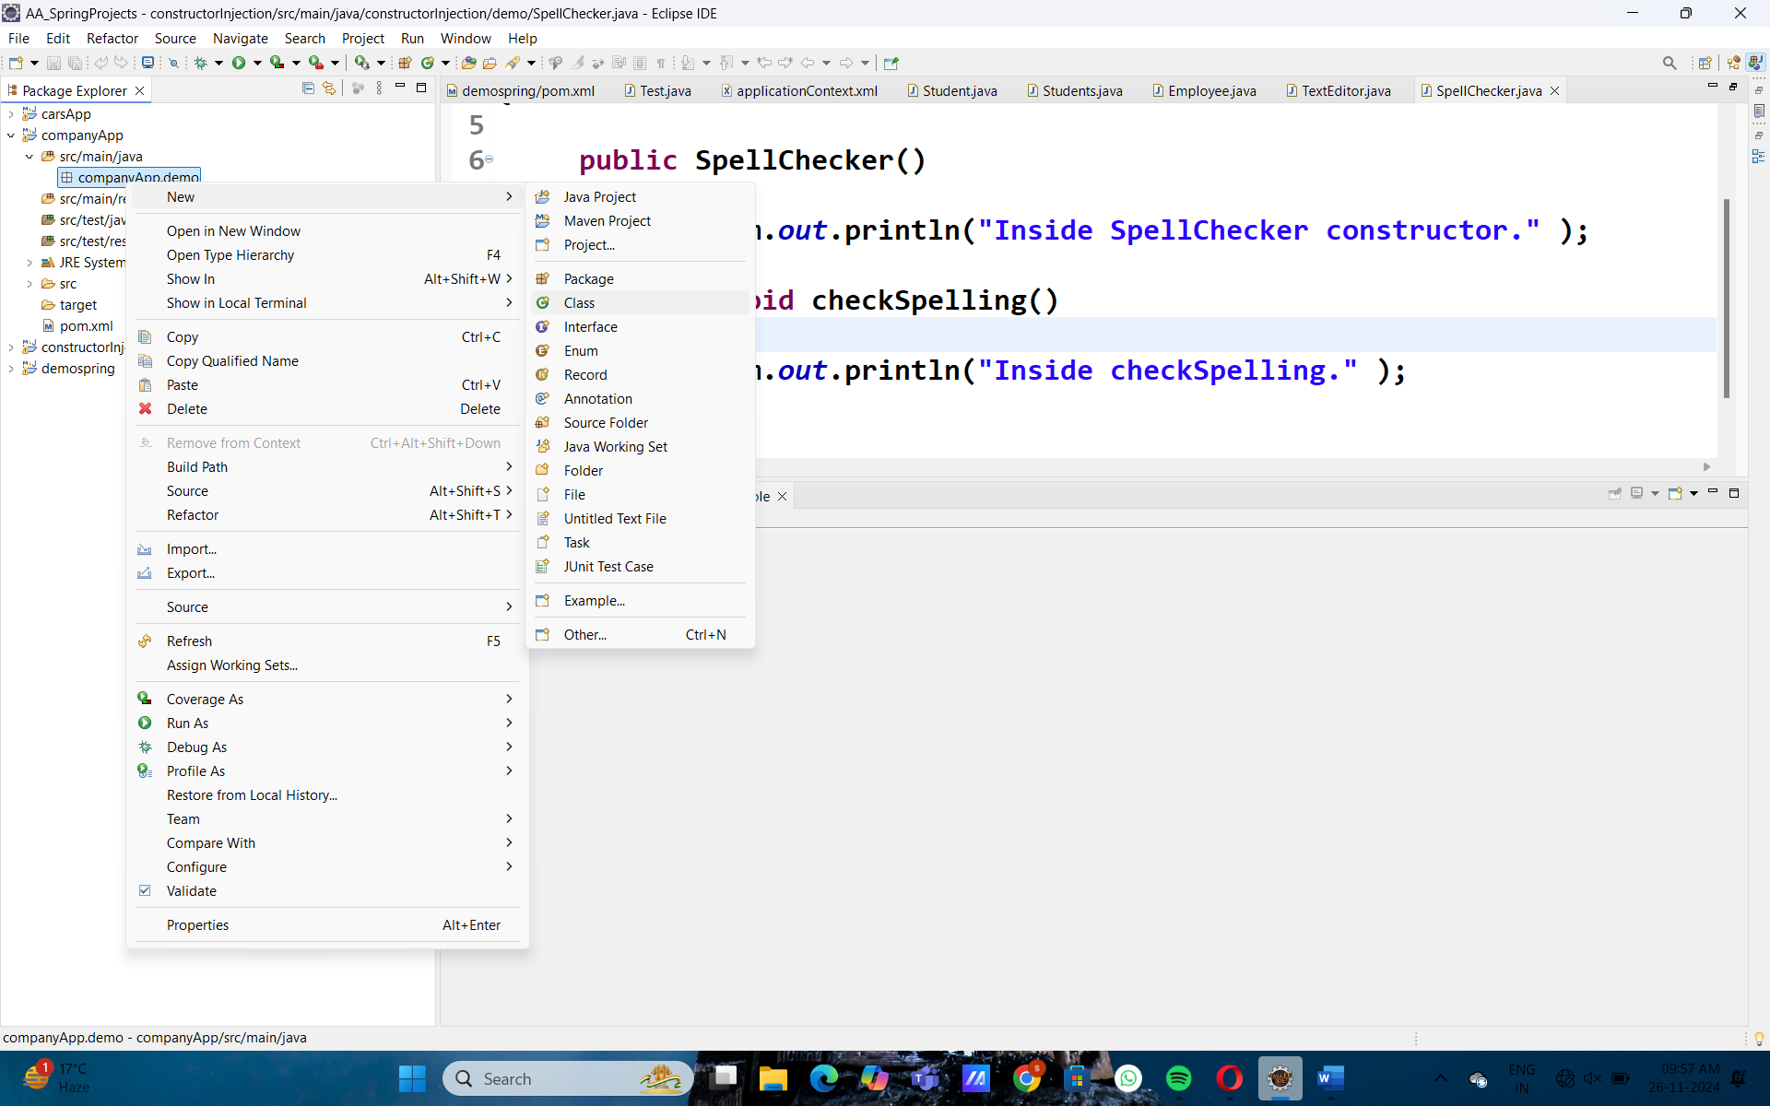
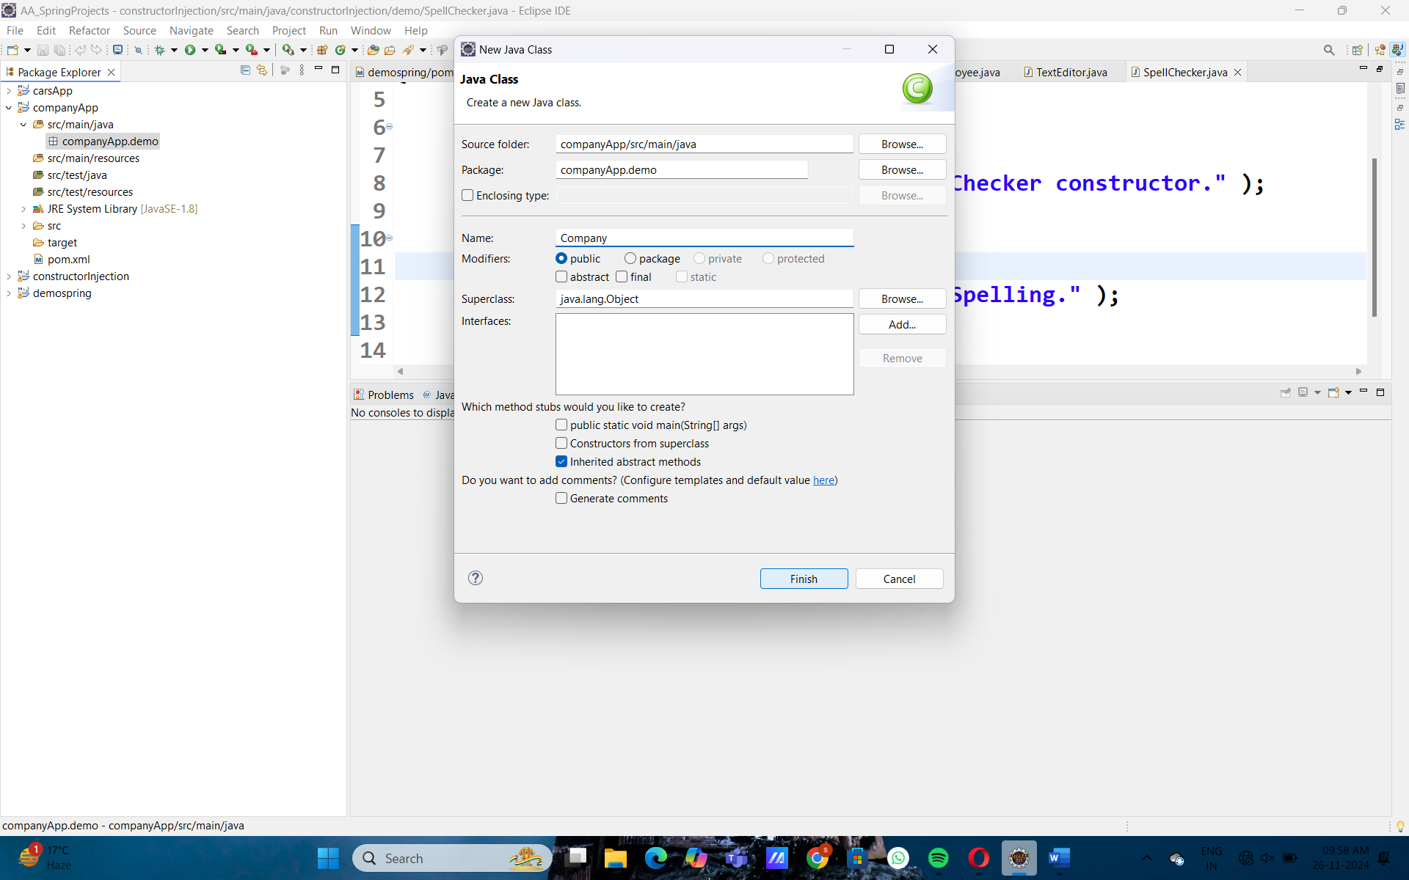
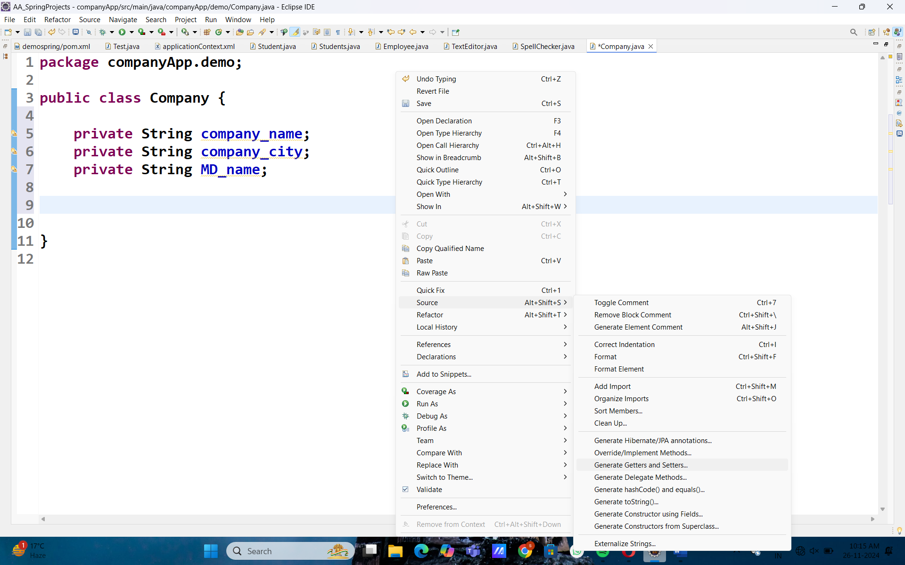

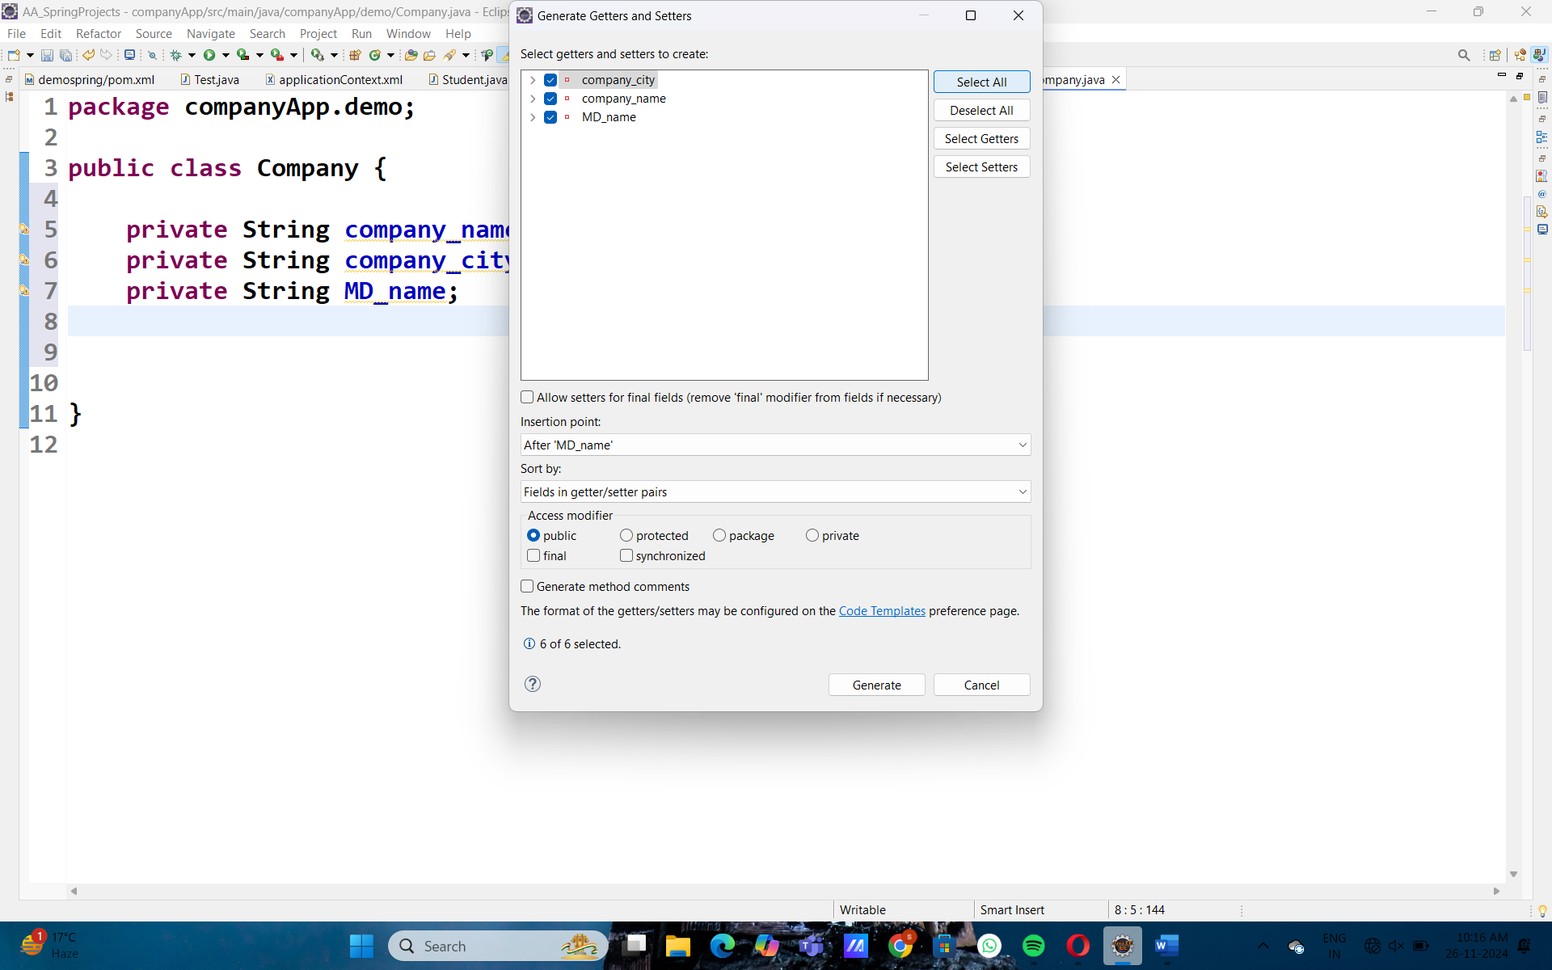
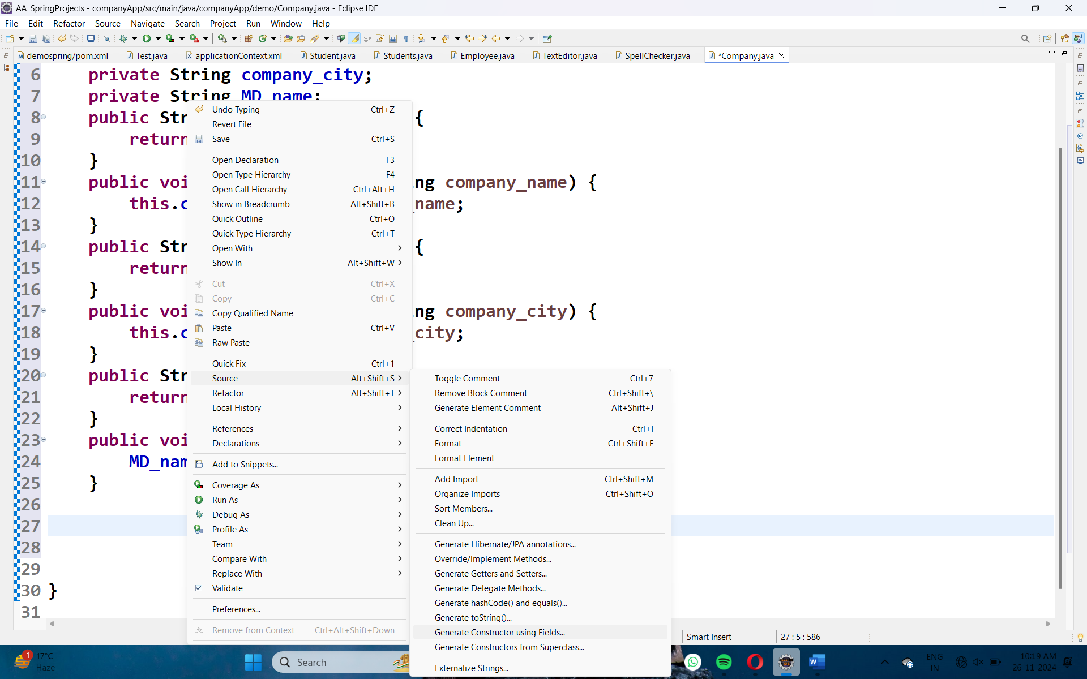

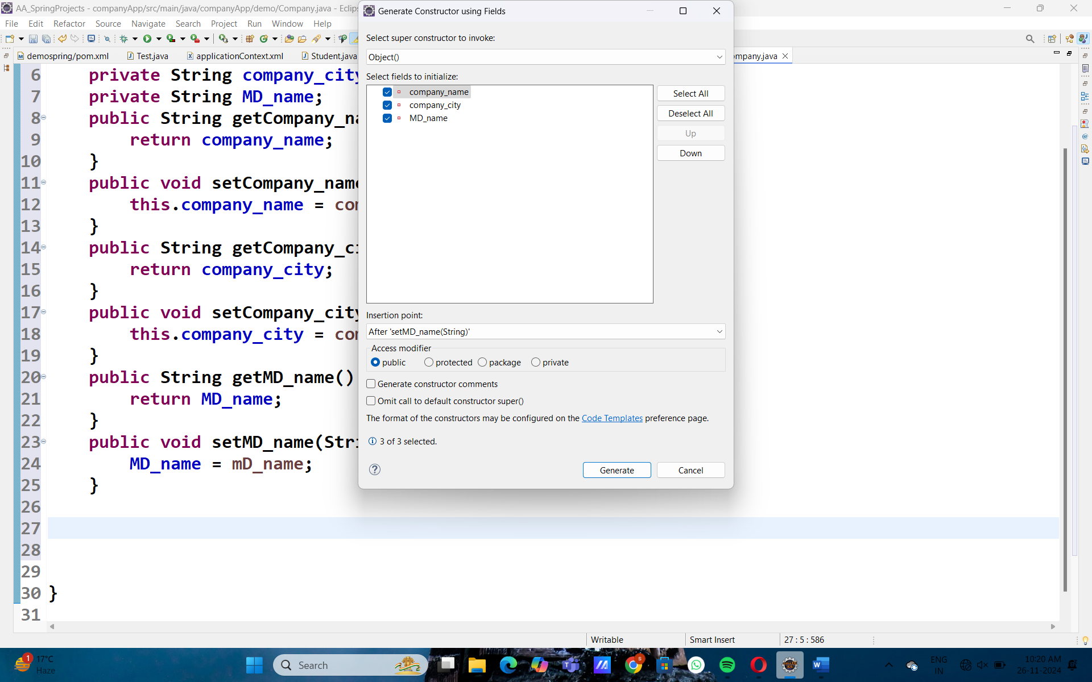
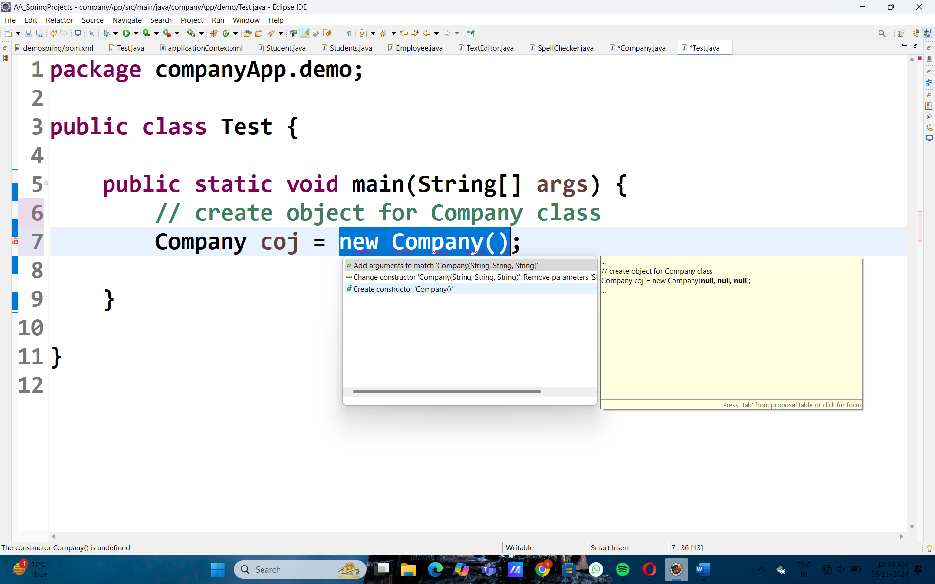
Create POJO class:
package companyApp.demo;
// this is POJO- PLAIN OLD JAVA OBJECT
public class Company {

private String company_name;
private String company_city;
private String MD_name;
public String getCompany_name() {
return company_name;
}
public void setCompany_name(String company_name) {
this.company_name = company_name;
}
public String getCompany_city() {
return company_city;
}
public void setCompany_city(String company_city) {
this.company_city = company_city;
}
public String getMD_name() {
return MD_name;
}
public void setMD_name(String mD_name) {
MD_name = mD_name;
}
public Company(String company_name, String company_city, String mD_name) {
super();
this.company_name = company_name;
this.company_city = company_city;
MD_name = mD_name;
}

public Company() {
// Zero args constructor
}
public void show()
{
System.out.println("Company Details "+company_name+ " Company Location "+company_city+" MD Name "+MD_name);
}
}

package companyApp.demo;

public class Test {

public static void main(String[] args) {
// create object for POJO Company class OR instantiating
Company coj = new Company();
coj.setCompany_name("Fashion Creators");
coj.setCompany_city("Greater Noida");
coj.setMD_name("Subbulakshmi");
// call or execute the show mehhtod
coj.show();
}
}

